1. **What location did you run this experiment from? (e.g. Home or some building on campus).**

I ran this experiment in LUMS E-LAB and also from M6 Hostel.

1. **Using the captured information only; what is the IP address of your machine?**

The IP Address of my machine is 10.130.21.68, since it is the source address when the first request is made to the destination which here is CNN.com.

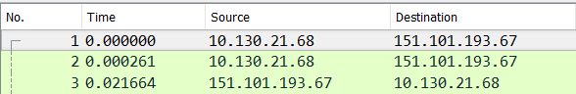

**C) What is the IP address of the Server hosting www.CNN.com? How did you find it from**

**the captured data? A very brief answer is needed. (Wasn’t working for Facebook).**

The IP address of the server hosting CNN is 151.101.193.67 since it is the initial destination address when the first request is made and is also the source address of the 3rd packet which is being received by my laptop.



**D) Do you also see other source and destination IP addresses in the packet trace? What do you**

**think are these?**

Yes, since the Wireshark is set to promiscuous mode, all the packets that are sent to my network shall be captured, (not only those which are meant for my PC).

It might also be that my request is being sent to some other server as well which might include Advertisement servers on CNN.com

**E) Will the captured packet trace show a different IP address for your machine if you change**

**your location (to another building on campus or a different home location)?**

Yes and No. No because since within the same network i.e. Wireless, I shall have the same IP Address, since that is what uniquely identifies me. I can confirm this from my results both in E-LAB and M6, which both show my IP Address as 10.130.21.68. Though Indeed, IP Addresses in Pakistan are not static, so it just might be that my ISP tends to assign me a new IP address but rather similar to the previous one. Indeed, if I go home, my IP Address would be different than that of what I am assigned using LUMS Network.

**F) Will the captured packet trace show a different IP address for www.cnn.com if you**

**change your location (to another building on campus or a different home location)?**

Yes, might be if the destination has multiple servers. Even if I don’t change to a different location within the same network and just clear my cookies, I might get assigned a Different Destination address for the same website as can be seen below.

Before:



After Clearing Cookies:



**G) What are the source and destination hardware addresses (or physical addresses or MAC**

**addresses) in the http GET request? Which one belongs to your machine? To which**

**machine/device does the other belong?**

The Source MAC Address is: (This belongs to my machine)

5C:EA:1D:25:F2:0B

The Destination MAC Address is:

AC:CF:85:C0:60:46 (This belongs to server’s)



**H) What are the source and destination hardware addresses in the http response? Which one**

**belongs to your machine?**

The Source MAC Address is: (This belongs to server)

AC:CF:85:C0:60:46

The Destination MAC Address is: (This belongs to me)

5C:EA:1D:25:F2:0B

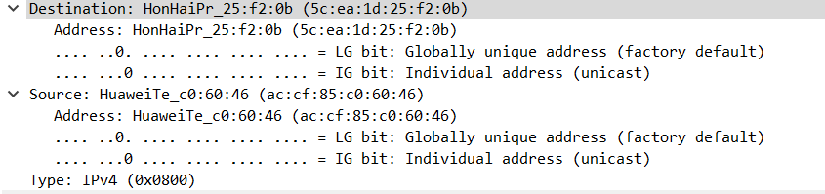

**I) What are the source and destination IP addresses in the http response? Which one belongs**

**to your machine? To which machine/device does the other belong?**

The Source IP Address is: 151.101.9.67 which belongs to the server of CNN

The Destination IP Address is 192.168.8.105 which belongs to my home IP Address

